THE e-ASIA JOINT RESEARCH PROGRAM

GUIDELINES FOR THE PARTICIPATION OF NEW MEMBER ORGANIZATIONS IN THE e-ASIA JOINT RESEARCH PROGRAM

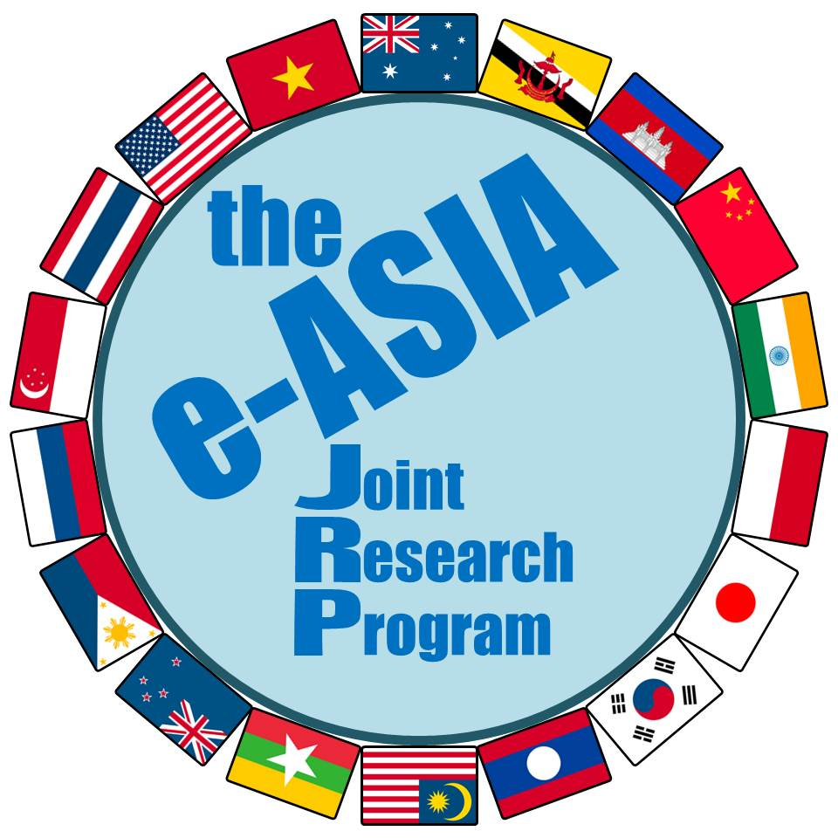

e-ASIA JRP
June 2018

GUIDELINES FOR THE PARTICIPATION OF NEW MEMBER ORGANIZATIONS IN THE e-ASIA JOINT RESEARCH PROGRAM
Introduction

Regarding the participation of New Member Organizations in the e-ASIA Joint Research Program (hereinafter referred to as the “Program”), a general consensus has been established in Item 2 and 4 of Article 4 of the Statute of the East Asia Science and Innovation Area Joint Research Program (hereinafter referred to as the "Statute"), as follows:

2. “Those eligible for Membership of the Program are ministries, agencies or other public/governmental bodies, which provide research fund, of East Asia Summit (EAS) participating countries, namely, Brunei Darussalam, Kingdom of Cambodia, Malaysia, Republic of Indonesia, Lao People’s Democratic Republic, Republic of Singapore, Republic of the Philippines, Republic of the Union of Myanmar, Kingdom of Thailand, Socialist Republic of Viet Nam, Australia, Japan, New Zealand, People’s Republic of China, Republic of India, Republic of Korea, Russian Federation, and the United States of America. However, the words “public” or “governmental” should be interpreted flexibly as long as candidate institutions have a competitive funding mechanism.”

4. New membership may be acquired by submitting a letter of intent (hereinafter referred to as an "LoI") for participation in the Program to the Program Secretariat. The Board will then consider approval of the new membership after deliberation on the degree of contribution the prospective member organization is able to make to the Program. The LoI must refer to this Statute, which describes essential elements of the Program. Prospective Member Organizations should refer to the “Guidelines for the Participation of New Member Organizations in the e-ASIA Joint Research Program”.

New membership is welcomed to encourage a broader participation of scientists from the Asian countries with research interests in the fields related to the Program and to provide greater opportunities to support multilateral joint research projects in the region.

In deciding on new membership, it is important to ensure the maintenance of the scientific quality of the Program, and especially the acknowledged excellence of its peer review system. In addition, the size of the Board, the Scientific Advisory Council (SAC) must be considered so as not to interfere with their effectiveness.

1. Membership terms

1) An organization wishing to become a Member Organization may apply in accordance with the procedures described in Article 2.

2) New Member Organizations approved for membership must appoint one person as its Board Member to represent the organization. Multiple Member Organizations from one single country have only one voting right. If there are multiple Member Organizations from one country, those Member Organizations will decide among themselves which of the Board Member hold the voting right

2. Procedures

1) Initial contact should be made with the Program Secretariat for information on the required procedure.

2). The organization should indicate the person that will be the point of contact for the Program and who will be responsible for communication.

.
3. A Letter of Intent should be signed by the appropriate person of the organization and formally submitted to the Board through the Program Secretariat.

4. The organization will be informed of the outcome by the Program Secretariat.

Procedure for the consideration of membership by the Board

The Board will take the following procedure into consideration when an application for membership is received:

1. If an organization contacts a Board Member directly, the enquiry will be referred to the Program Secretariat.

2. The Program Secretariat will place the issue on the agenda for either the Ad Hoc Board Meeting or the Annual Board Meeting.

3. Approval of membership requires a two-thirds majority vote by the Board Members.

Originally approved on June 5, 2013 at the 2nd Annual Board meeting
Revised on June 8, 2018

